LLM and AI Agent Applications with LangChain and LangGraph

Part 15: Evaluation and LangSmith

In this part we’ll focus on a topic that is absolutely key when working with LLMs: evaluation of outputs.
LLMs generate non-deterministic answers, so evaluation can be tricky. The good news is that today we already have techniques that work really well in practice — and in this module I’ll walk you through them.
In this episode I’ll introduce LangSmith.
LangSmith is an environment built by the creators of LangChain. It helps you monitor, analyze, and evaluate LLM-powered applications. With LangSmith you can not only track which prompts and responses flow through your system, but also systematically measure quality and verify correctness.

What is LangSmith made of?
LangSmith consists of a few key building blocks:

Tracing
Tracing means tracking the full history of model calls — prompts, responses, timing, and costs.
This makes it much easier to understand how your app behaves and where problems show up.

Datasets
Datasets are test sets you can use for repeatable evaluation. For example: a collection of questions and expected answers for your application.
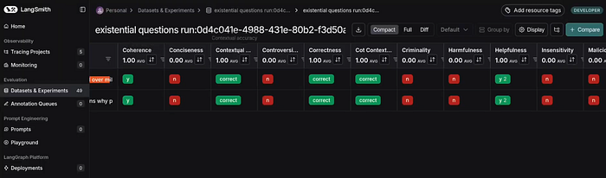
Criteria evaluation results in LangSmith

Evaluators
Evaluators are methods used to score output quality. This includes semantic evaluation, criteria-based evaluation, reference comparisons, or format validation.

Feedback and A/B testing
A way to compare answers, pick the better version, and rate results directly in a user interface.

Integration with LangChain and LangGraph
All chains and agents can report runs directly to LangSmith — often with no extra glue code.
Because of this, LangSmith becomes a kind of command center for LLM applications: one place where development, monitoring, and evaluation meet.

Evaluation techniques: what works and when
There are many evaluation techniques, and each one shines in different situations.
1) Criteria Evaluator
Here, a model such as GPT-4o or Claude evaluates a generated answer on a 1–5 scale, using selected criteria.
You can score things like correctness, clarity, usefulness, or avoidance of harmful content.
2) Embedding Distance Evaluator
This method compares the model’s answer to a reference answer using semantic vectors (embeddings).
Thanks to embeddings, we can measure similarity of meaning — even when the wording is different.
3) String comparison metrics
These are classic text metrics like ROUGE, BLEU, or METEOR.
They measure overlap with the reference at the token level. This approach is simpler and less flexible, but it’s still useful for tasks that require strict matching.
4) Trajectory Evaluator
This one evaluates whether the model followed the right reasoning path — not just whether it produced the correct final answer.
We compare the step-by-step “trajectory” of the model’s reasoning with a reference trajectory. This becomes especially important in tasks where the process must be safe and correct, not only the outcome.
5) Classic A/B tests
Finally, we have standard A/B tests: compare two answers and select the better one — for example in terms of relevance or clarity.
That’s all in this chapter introducing to LLM output evaluation.
In the next episodes I’ll go deeper into each category of evaluators and show practical examples of how to use them directly in application code.

